Bailey Frame Change
A method of moving bees on to new comb without sacrificing eggs and brood.
The bees are gradually moved from the pink brood box to the green one.

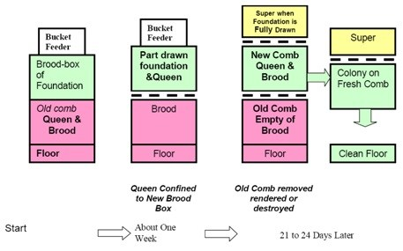

- Prepare a clean brood box filled with frames of foundation (Green)
- Place this box over your current brood box (Pink)
- Feed with thick sugar syrup (1/2 litre of water to 1 kilogram of sugar), unless there is a strong nectar flow on, to get the bees drawing the comb in the new box
- When the bees have drawn out some of new foundation, find the queen and place her on this comb.
- If your bees need more space: Leave the queen excluder over the old brood box and place another over the new brood box, trapping the queen in the upper box.
- If possible, arrange a new hive entrance between the two brood boxes and close off the old, thus helping to reduce the amount of pollen stored in the old lower combs.
- After three weeks the brood in the original brood chamber will have emerged and you can take it away.
- The comb can then be rendered to recover the beeswax.

Adapted from www.talkingwithbees.com

